Marc Bacarro, Nathan Graham, Nazeer Hyder, Nicole Rosteski, Amelia Winczura
Mentor: Dr. Page Edgar

ABSTRACT
The game Rush Hour® was used to evaluate focus and concentration in medical school students. There were 65 individuals that participated in the study. One participant was excluded because they failed to complete the task. Of the 65 participants, 37 stated that they ate breakfast and broke their fast prior to engaging in focus and concentration activities. The other 28, were of the fasting group, and did not break their overnight fast prior to engaging in academic activities. The null hypothesis stated that there is no significant difference between focus and concentration requiring tasks when consuming breakfast. The alternate hypothesis stated there is a significant difference in concentration and focus related tasks when students consume breakfast. A t-test was conducted comparing game playing time in those that were in the fasting group compared to the non-fasting group. A p-value of 0.19 was obtained, failing to accept the null hypothesis. Gender differences, caffeine consumption and prior game experience were also explored. A t-test for caffeine consumption in the non-fasting group was done and a p-value of 0.048 was obtained indicating significance. In the cohort of participants who had not previously played the game Rush Hour®, there was a significant difference between fasting and non-fasting times. Further research should be done to explore effects of sleep and quality of sleep, performance enhancing drug use, further effects of caffeine, pre-fast meal contents and quality, and duration of fast on focus and concentration.

KEYWORDS
Concentration, focus, medical students, Rush hour®, fasting state, non-fasting state, breakfast, games, overnight, consumption, attention, puzzle card, cars, trucks, six-by-six grid, participants

OBJECTIVES AND AIMS
What is the effect of overnight fasting on focus and concentration compared to a non-fasting state in medical students evaluated by performance time when playing the game Rush Hour®?
The null hypothesis for this experiment is that there is no significant difference between focus and concentration requiring tasks when consuming breakfast. The alternate hypothesis for this experiment is that there is a significant difference in concentration- and focus-related tasks when students consume breakfast.

INTRODUCTION/HISTORY
Concentration has been a long running topic within society that has garnered much attention within the scientific community. With the rising incidence of individuals diagnosed with attention, focus, and concentration disorders, as well as those who are not diagnosed but have trouble focusing for various reasons, there has been an increase in studies that have tried to address this idea of understanding and improving concentration. The activities of people’s daily lives have been studied in order to understand whether or not what one does every morning or what one does in general affects the ability to concentrate. As such, the aim of this project is to determine if fasting has an effect on concentration and focus in medical students. It is hypothesized that students that consume breakfast will perform better on focus and concentration requiring tasks.

Fasting versus non-fasting states
Breakfast is a name that has been overlooked as having a significant meaning, as the words “break” and “fast” have been brought together to signify a meal that breaks a fast that occurs overnight. Western society has acknowledged breakfast as an important meal, but how important, and how does it affect focus and concentration? Ackuaku-Dogbe et al. stated that, generally, breakfast skipping was related significantly to fatigue and poor attention during clinical sessions.¹ Pollitt et. al. found that the consequences of an overnight and morning fast, particularly among children who were nutritionally at risk, included slower stimulus discrimination, increased errors, and slower memory recall.² Based on the results from the Schefte and Rosenstick study, researchers determined that a 17-hour fast does not deteriorate surgical performance in medical residents.³ These conflicting results have led us to propose a similar study regarding medical students. The intent of this study is to expand on the current research regarding fasting and its effect on concentration and focus.
As many as seventy-two percent of medical students skip breakfast at least once a week, with females skipping breakfast more often than men do.¹ Medical students skip breakfast because of personal choice, insufficient time, eating time preferences, little appetite, or they oversleep. The largest contributing factor is the availability of time to eat breakfast prior to the first lecture of the day. Not eating breakfast has been found to increase fatigue and cause lack of concentration.¹ Other students have reported feeling only slightly tired or not tired at all after consuming breakfast. Additional factors relevant to performance are related to fatigue, including lack of sleep and exercise; however, these will not be considered in our study design.¹ This study will also attempt to determine how many students at Saint James School of Medicine normally skip breakfast prior to coming to class.
A fast of six to ten hours is normal for most people overnight, with metabolic changes limiting the use of carbohydrates and fat breakdown for energy. Increased rates of gluconeogenesis from amino acids, glycerol, and ketone bodies help to maintain the supply of carbohydrates during the fasting period. The first stage of fasting is classified as the postabsorptive period. This period occurs once all of the nutrients ingested after the last meal have been absorbed from the small intestine, lasting three to eight hours, based on the meal consumed. The early stages of fasting last for 24 hours following the last meal consumed. During this period, the body functions without nutrients that normally would be consumed. When blood glucose is maintained within normal levels the breakdown of liver glycogen stores occurs through hydrolysis, and releases glucose into circulation.⁴ This is the reason the body can continue to function after fasting for a certain period of time.
The liver stores about an average of 60 grams of glycogen. The glycogen is released at a rate of about 4 grams of glucose per hour, which affects the metabolic rate minimally when fasting. Oxidative metabolism releases enough energy to meet the body’s general and resting requirements. Carbohydrate utilization is decreased in a fasting state and one’s energy is supplied with an increased rate of fat oxidation. This spares the body’s limited carbohydrate reserves for tissues needing carbohydrates for example, the central nervous system. Triglycerides from adipose tissue, leading to an increase in the circulating concentration of free fatty acids in the plasma, provides energy for gluconeogenesis and a systemic supply of blood glucose.⁴

Cognition testing
Concentration as well as other cognitive functions such as memory and cognition have been evaluated in numerous ways. Some researchers have evaluated concentration, memory, and cognition through video games and board games, such as chess. Chess is a game that involves many aspects of high-level cognition and requires sophisticated problem-solving skills.⁵ Some companies claim to improve cognition and concentration, such as Lumosity®, which is a web-based application that uses games to improve cognitive abilities.⁶ Other data shows that fluid intelligence can predict performance in reasoning games, especially those that involve novel tasks.⁷ Aliyari et al. examined the effects of computer games on changes in brain waves (EEGs) and cognitive function.⁸ The results of the study showed that sustained attention increased in participants after playing the game in comparison to the results prior to playing.
In this proposed experiment, the game Rush Hour® will be used to test medical students’ focus and concentration. Rush Hour® is a children’s game that demands visual problem solving, critical thinking, and strategy development. Rush Hour® has received numerous awards, including the Mensa Select Award.⁹ The Mensa Select Award acknowledges five board games annually that are original, challenging, and well designed.
The Rush Hour® playing board is a six by six-inch grid with grooves in the tiles to allow cars and trucks to slide. The goal of the game is to get the red car out of a six-by-six inch grid full of automobiles by moving other vehicles out of its way. However, the cars and trucks which are set up before play, according to the desired puzzle card, obstruct a clear path which makes the puzzle much more difficult. There is an exit hole on one end of the board where only the red car can escape. The game comes with twelve cars and four trucks, each varying in color. The cars take up two squares each and the trucks take up three squares each. There are puzzle cards that come with the game and depending on whether or not one has an expansion pack determines the number of puzzles one can play. The cards have a difficulty level number, where the higher the level, the more difficult the puzzle. Each puzzle or challenge card has a solution on the back. However, it is important to keep in mind there may be many solutions to each puzzle. The puzzle card shows which colored cars get placed on the board and where on the board they should be placed. Cars and trucks can only be moved within a straight line along the grid and no pieces can be rotated or picked up at any time during the game.
As stated above, there are many solutions to each puzzle card. This type of game is known as a PSPACE complete game. PSPACE games can be defined as games of decision - problems solvable in polynomial space.¹⁰ These types of games are much more difficult to perform because a solution to one problem could easily solve another problem, making this type of problem-solving almost infinite among the solutions possible. However, due to the move constraints provided by the game, there are solutions that are more efficient that will solve the problem without it overlapping with another similar type of problem.

METHODS.

Apparatus
Approximately 65 medical students were recruited from Saint James School of Medicine to participate in the study. The participants will be given a short questionnaire including information such as date of birth, gender, last time the food was consumed, and whether or not the participant consumes breakfast on a daily basis (Appendix A).
The board game Rush Hour® was chosen to assess focus and concentration on fasting and non-fasting students. A stopwatch on an iPhone will be used to time how long it takes the students to complete the task. This time includes only the time it takes for the participant to move cars and trucks around in order to get the red car out of the grid. As soon as the game is revealed to the participant the stopwatch will be started. Then as soon as the red car leaves the grid, the stopwatch will be stopped and total time will be recorded. This does not include setup time or resetting the game playing board. The researcher will do this after the participant is completely done with testing. The game is assessed in an isolated area to limit distractions and prevent the waiting participants from observing the solutions to the problems. Data will be recorded on an excel spreadsheet. A unpaired t-test obtaining a p-value for the level of significance against a null hypothesis will be used for this cross-sectional study using excel software. The null hypothesis for this experiment is that there is no significant time difference between focus and concentration requiring tasks whether breakfast is consumed or not. The alternate hypothesis for this experiment is that there is a significant time difference in completing concentration and focus requiring tasks when students consume breakfast.

Procedure
A preliminary survey was conducted asking how many students consume breakfast on a daily basis compared to those that do not consume breakfast. Participants were asked to follow their normal daily routine and were classified and added to either the fasting group or non-fasting group based on their daily routine. Inclusion into the fasting group is classified by not consuming anything other than water after midnight the day prior to testing.
After informed consent (Appendix B), participants were be given a paper with instructions to follow in regards to data collection on the day of the study (Appendix C). Students were asked to follow their normal daily routine regarding eating breakfast or not eating breakfast prior to coming to school in the morning. Those that do not consume breakfast will be put into one sample group, denoted as the fasting sample group, and completed the timed puzzle task. Those that normally consume breakfast will be placed into another group denoted as non-fasting group, and completed the timed puzzle task. On the day of data collection, the participants were asked to follow their normal daily routine of consuming breakfast prior to completing the timed puzzle task. The participants will not be told what game they would be playing until they arrived at the testing center. The testing occurred over the course of a few days in order to successfully test all subjects.
On the morning of the testing, students were asked to arrive at the testing center by 7:30 a.m. in order to have the testing completed prior to 8 a.m. classes. Once there, the participants signed in on a numbered list. This assigned them a pseudonym and allowed the participants to remain anonymous. The sign-in list was destroyed after the study to ensure the anonymity of the participants. Those that were in the fasting group had a number in addition to the letter “F” to differentiate the fasting students from the non-fasting students denoted by “NF”. For example, participant 1 in the non-fasting group was assigned participant number 1NF and participant 2 who is in the fasting group will be assigned participant number 2F. The letter “F” denotes participants in the fasting group, and the letters “NF” denotes participants in the non-fasting group.
Once signed in, the participant was be given a questionnaire corresponding to their pseudonym on the sign-in sheet. They were also given a consent form and a paper copy explaining the study with written directions on how the game is to be played and how the study was to be conducted (Appendix D). The participants then were tested in an isolated room to limit the distractions and prevent observation from the other participants.
The game board for the beginner card one was sitting on the table in the assessment room covered. The timer, used on an iPhone, was started when the cover was removed and the puzzle was revealed. The participant was timed on how long it took them to complete the puzzle. The timer was stopped when the car left the board. When the participant was finished they were asked to not speak about the study or the game until all data had been collected from all participants.
By assigning a task that required focus and concentration the timed data was used to assess how the participant's focus and concentration in the fasting group is compared to those that are in the non-fasting group. Quicker times would indicate that eating breakfast does play a role in focus and concentration.

RESULTS

Demographics
The purpose of the study was to determine if overnight fasting affects focus and concentration using the game Rush Hour® and the impact of gender, prior experience with Rush Hour® or a game of similar variant, and caffeine consumption.
There were 65 individuals who participated in the study. One person was excluded because of failure to complete the task. The study included 42 (64.62 %) females and 23 males (35.38 %). The age of the participants ranged between 22 years and 50 years (mean = 27 years). There were 49 individuals stated that they exercised prior to the study, 14 individuals stated they did not exercise prior to the study. One participant chose not respond.

Figure 1: Fasting and Non-Fasting groups

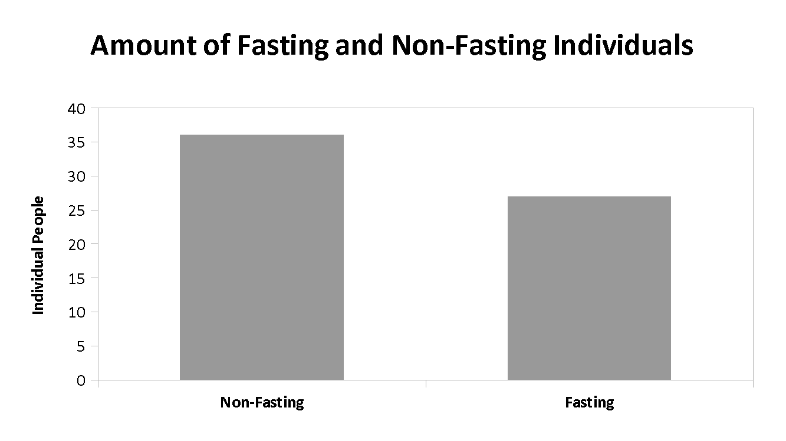

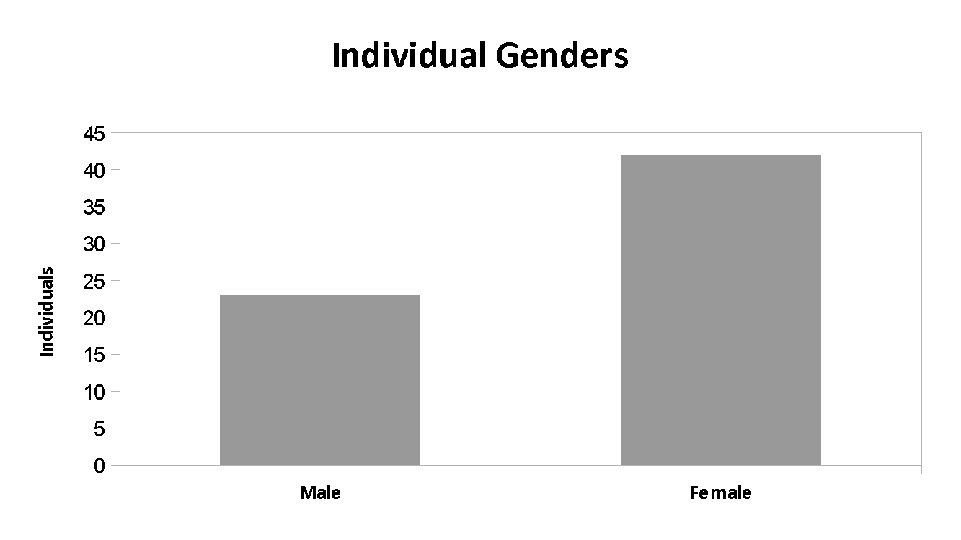
Figure 2: Male and Female Participants

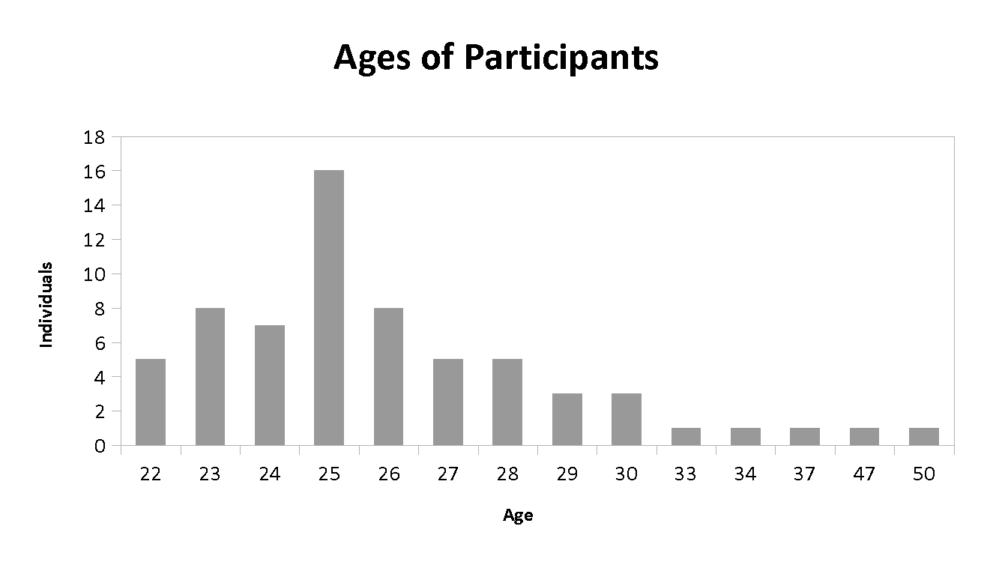
Figure 3: Age distribution

Fasting vs Non-fasting
Of the 64 participants included in the study, 36 individuals had breakfast and broke their fast prior to engaging in focus and concentration (Non-Fasting). 28 participants did not break overnight fast prior to engaging in academic activities (Fasting).

The Non-Fasting group (n = 36) had a faster mean completion time of 31.8 seconds +3.18 (SD=19.10) with a median of 27.55 seconds and mode of 13.82 seconds than the fasting group, which had a mean completion time of 41.90 seconds (SD=40.89) with a median of 32.12 seconds (Table 1). No significant difference in focus and concentration was found between the non-fasting and fasting groups (t (62) = 3.118, p = 0.194). An outlier was identified and removed from the Fasting group based on interquartile ranges. However, no significant difference in focus and concentration was found between non-fasting and fasting groups, (t (61) = 0.6675, p = 0.507).
Table 1. Average completion time (in seconds) of Rush Hour® task of the fasting group (n = 28) and non-fasting group (n = 36).
 | Non-Fasting | Fasting
Mean (SD) | 31.80 + 3.18 (19.10) | 41.90 + 7.23 (40.90)
Median | 27.56 | 32.125
Mode | 13.82 | N/A

Figure 4: Comparison of mean completion time between Non-Fasting vs. Fasting individuals
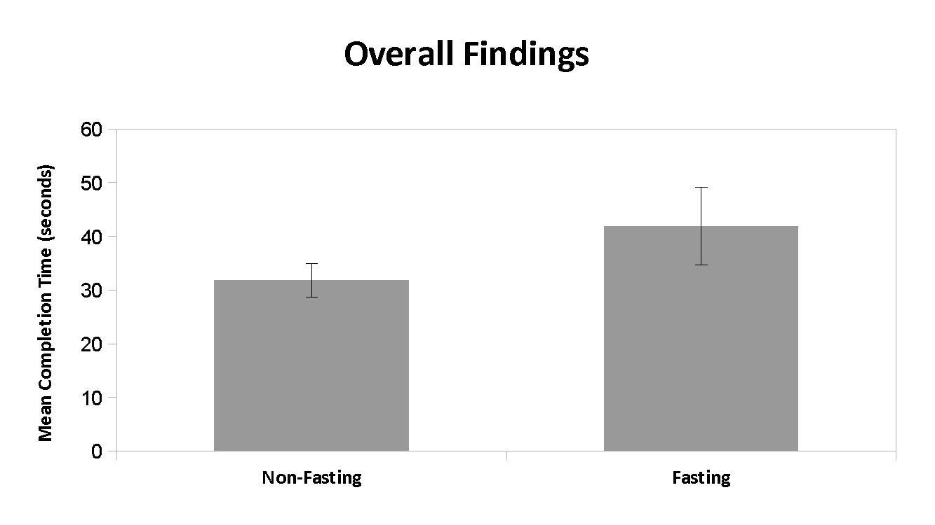

Gender Comparison
To compare the difference in focus and concentration on the Rush Hour® task between genders, the participants were divided into four groups: non-fasting males (n = 11), fasting males (n = 12), non-fasting females (n = 25), and fasting females (n = 16) (Table 2). In male participants, the non-fasting group had a faster mean completion time of 30.70 + 6.25 seconds (SD = 20.72, Median = 23.54 seconds) than the fasting group that had a mean completion time of 48.17 + 16.53 seconds (SD = 57.25, Median = 33.65). No significant difference in focus and concentration was found between non-fasting and fasting male participants (t (21) = 0.9549, p = 0.3505).

In females, a similar trend was observed; such that, the non-fasting group had a faster mean completion time of 32.28 + 3.75 seconds (SD = 18.77; Median = 28.76; Mode = 13.82) than the fasting group that had a mean completion time of 37.20 + 5.87 seconds (SD = 23.47; Median = 30.25) (Table 2). No significant difference in focus and concentration was found between non-fasting and fasting female participants (t (39) = 0.7421, p = 0.4625).

Comparing non-fasting males and females, it was found that non-fasting males had a faster mean completion time than non-fasting females. No significant difference in focus and concentration was found between non-fasting males and females (t (34) = 0.2251, p = 0.8233).
Meanwhile, fasting females had a faster completion time than fasting males. However, no significant difference in focus and concentration was found between the fasting males and females (t (26) = 0.6962, p = .4925).

Table 2. Average completion time (in seconds) of Rush Hour® task of males in non-fasting (n = 11) and fasting (n = 12) groups; and females in non-fasting (n = 25) and fasting (n = 16) groups.
 | Male (n = 23) |  | Female (n = 41)
 | Non-Fasting | Fasting | Non-Fasting | Fasting
n | 11 | 12 | 25 | 16
Mean (SD) | 30.70 + 6.25 (20.72) | 48.17 + 16.53 (57.25) | 32.28 + 3.75 (18.77) | 37.20 + 5.87 (23.47)
Median | 23.54 | 33.65 | 28.76 | 30.25
Mode | N/A | N/A | 13.82 | N/A

Prior experience with Rush Hour.
To determine the effects of prior experience in fasting and non-fasting participants completing the focus and concentration task, the participants were divided into 4 groups: Non-fasting individuals with no prior experience to Rush Hour®. (n=26), Fasting individuals with no prior experience to Rush Hour®. (n=27), non-fasting individuals with prior experience to Rush Hour®. (n=11), or fasting individuals with prior experience to Rush Hour®. (n=1).

Due to such a small sample size, comparisons could not be made with the population that had no prior experience with Rush Hour® and were also fasting.

In comparing participants who have had no prior experience, it was found that non-fasting individuals had a non-significant faster completion time than those who did fast (t(51) =0.76 , p= 0.45 ). However, individuals who did not fast and had prior exposure to the game had a significantly faster time than those who did not have prior experience (t(34)=2.05, p=0.046* , 95% CI = 0.09 to 27.74).
Table 3. Average completion time (in seconds) of Rush Hour task of non-fasting individuals with no prior experience to Rush Hour® (n=26), Fasting individuals with no prior experience to Rush Hour® (n=27), non-fasting individuals with prior experience to Rush Hour® (n=11), or fasting individuals with prior experience to Rush Hour® (n=1). ( * denotes significance)

 | No Prior Experience with Rush Hour® or similar (n = 53) |  | Experience with Rush Hour® or similar (n = 11)
 | Non-Fasting | Fasting | Non-Fasting | Fasting
n | 26 | 27 | 10 | 1
Mean (SD) | 35.66 + 3.89  (19.80) | 42.50 + 8.00  (41.54) | 21.76 + 4.17*  (13.19) | 25.76 + 0  (0)
Median | 31.35 | 32.23 | 16.23 | N/A
Mode | N/A | N/A | N/A | N/A

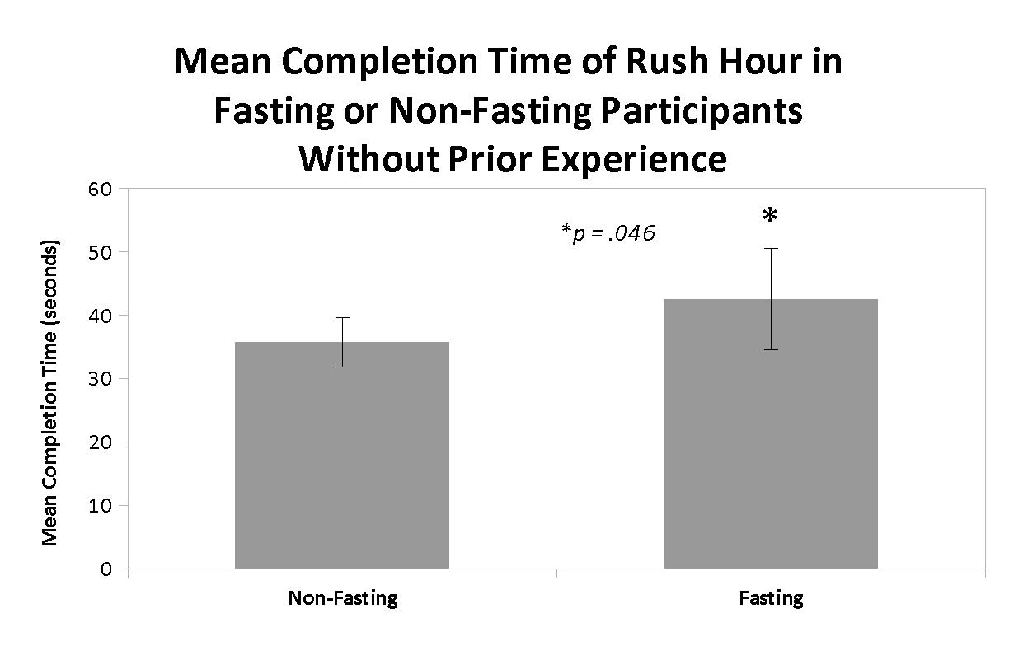
Figure 5. T-test indicates a significant difference in the mean completion time of Rush Hour®, a measure of focus and concentration in individuals without prior experience comparing (p = 0.046* ). (*denotes significance)

Caffeine consumption
To determine the effect of caffeine consumption in fasting and non-fasting participants completing the focus and concentration task, the participants were divided into 4 groups: non-fasting with caffeine consumption (n = 12), fasting with caffeine consumption (n = 5), non-fasting without caffeine (n = 24), and fasting without caffeine (n = 23). No significant difference was found between non-fasting and fasting participants who consumed caffeine (t (15) = 1.0409, p = 0.3144).
There was also no significant difference in focus and concentration found in non-fasting and fasting participants who did not consume caffeine (t (45) = 1.7765, p = 0.0824).
In comparing fasting participants, it was found that participants who did not consume caffeine had a non-significant faster completion time than those who consumed caffeine (Table 4). (t (33) = 0.2874, p = 0.7756). Meanwhile, non-fasting participants who did not consume caffeine had significantly faster mean completion time in the focus and concentration task than the non-fasting participants who consumed caffeine (t (34) = 2.0521, p = 0.0479, 95% CI = 0.13 to 26.39) (Table 4; Figure 1).
Table 4. Average completion time (in seconds) of Rush Hour® task of non-fasting participants with caffeine consumption (n = 12) and fasting with caffeine (n = 5) groups, non-fasting participants without caffeine (n = 24) and fasting participants without caffeine (n = 23). (* denotes significance)
 | Caffeine (n = 17) |  | No Caffeine (n = 47)
 | Non-Fasting | Fasting | Non-Fasting | Fasting
n | 12 | 5 | 24 | 23
Mean (SD) | 40.64 + 6.41* (22.21) | 29.56 + 5.33 (11.92) | 27.38 + 16.06 (16.06) | 44.58 + 9.28 (44.54)
Median | 34.78 | 32.23 | 23.49 | 32.02
Mode | N/A | N/A | N/A | N/A

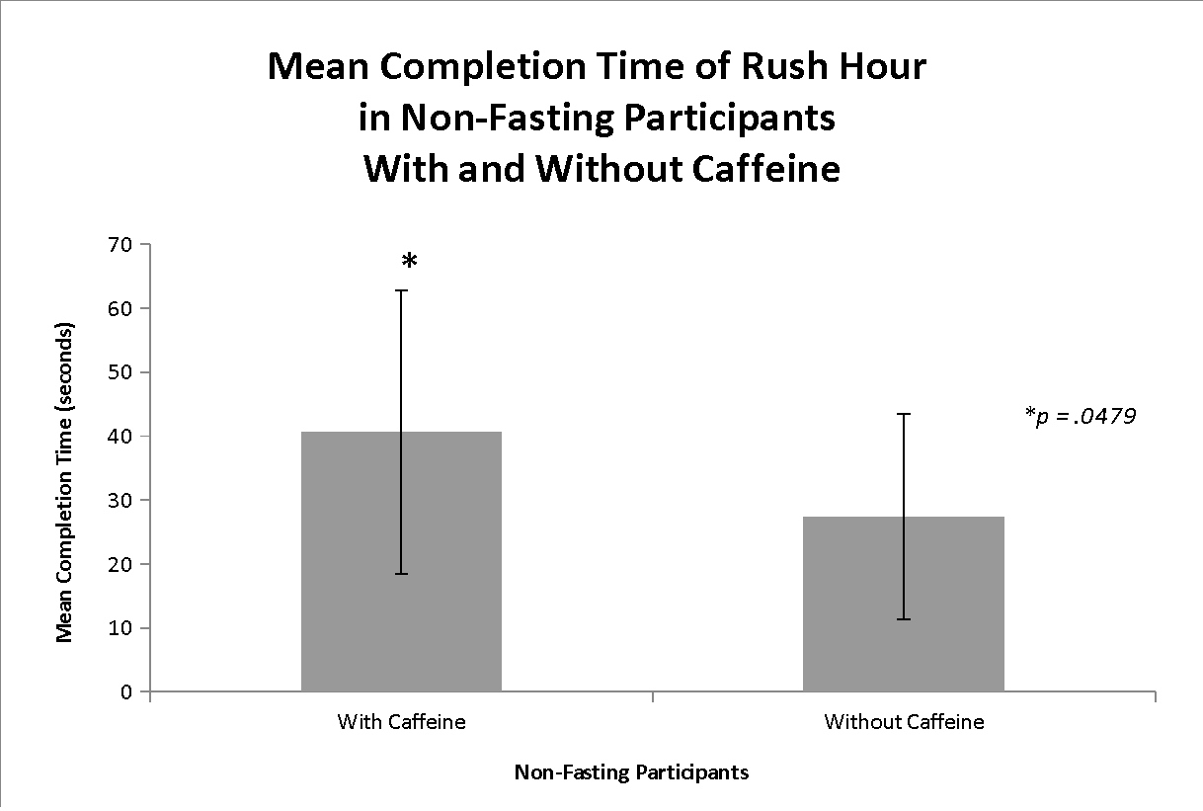
Figure 6. T-test indicates a significant difference in the mean completion time of Rush Hour®, a measure of focus and concentration, between non-fasting participants with and without caffeine consumption (p = 0.0479* ). (*denotes significance)

Summary of Results
Overall, the study found that there was no effect of overnight fasting focus and concentration (t (62) = 3.118, p = 0.194). However, when taking into consideration gender, prior experience with the game Rush Hour®, and caffeine, significance was found within some of these samples, particularly within the prior experience and caffeine sample groups.
Within the population of those who have had prior experience with the game Rush Hour®, a significantly faster mean task completion time was found within the non-fasting group when comparing experience level (t(34)=2.05, p=0.046, 95% CI = 0.09 to 27.74). Within the population of those that consumed caffeine prior to the study, a significantly faster mean task completion time was also found within those that did not consume caffeine and did not fast compared to those who consumed caffeine and did not fast (t (34) = 2.0521, p = 0.0479, 95% CI = 0.13 to 26.39).

DISCUSSION
This study explored the possibility of a relationship between focus and concentration when fasting with medical students prior to starting morning academics through evaluating performance times when playing the game Rush Hour®. An observational, cross sectional study was administered. 64 participants completed a mental puzzle and filled out a questionnaire to determine if there were any trends between breakfast consumption and its effects on concentration. In the experiment, fasting was defined as not consuming any food after waking until after the administration of the test. The differences in trends between males and females were examined to determine whether or not the participants had played Rush Hour® before and consumption of caffeine.
As seen in the above results, there were 36 participants in the non-fasting (11 male, 25 female) category and 28 were in the fasting category (12 male, 16 female). This can be seen in Figure 1 and Figure 2. Figure 3 shows the breakdown regarding the age distribution of participants. The non-fasting group had a mean of 31.80 seconds (sec) and standard deviation of 19.10 sec (Table 1). In comparison, the fasting group had a mean of 41.90 sec and a standard deviation of 40.90 sec. The large difference in the standard deviation is likely due to the large differences in the ranges between the two groups. The non-fasting group had a range of 70.79 sec (11.41 sec-82.2 sec), whereas the fasting group had a range of 215.98 sec (10.17 sec -226.15 sec).
An unpaired t-test was performed on the data, comparing the fasting and non-fasting results with alpha at 0.05. The null hypothesis (H₀) stated there is no significant difference between focus and concentration requiring tasks when consuming breakfast. The alternative hypothesis (H_{a}) stated there is a significant difference in concentration and focus related tasks when students consume breakfast. Based on the results stated prior, we failed to reject the null hypothesis (p=0.194) There was no significant evidence to support the effect of fasting on focus and concentration. In healthy medical students, it has been shown that choosing or not to break their fast in the morning will not enhance or decrease their performance. The results found in our study are consistent with the results achieved from Iovino, et al; there is no significant difference when comparing fasting and non-fasting cognitive performance.¹⁸ Breakfast consumption has no significant short-term effects on healthy medical school students. The performance was repeatedly seen to be consistent despite varying factors, showing no significant difference in results. Not eating breakfast has been found to increase fatigue and cause lack of concentration contradicting research by Ackuaku-Dogbe, Abaidoo, et al.¹
It is worth mentioning other trends the data showed. The data showed that in the cohort of participants who had not previously played the game Rush Hour®, there was a significant difference between fasting and non-fasting times. Within the cohort that did not have prior experience, we found a significantly faster completion time in those that did not fast versus those that did fast. When you take into consideration experience, though the tests showed no significance between the experience cohorts, by removing the experience variable, we achieved a significant value, possibly leading to a limitation or confounding value that can be taken into consideration in future studies.
In separate t-tests potential confounding factors were examined; male vs female, caffeine consumption and history of playing Rush Hour®. Caffeine was found to be a potential confounding factor in the non-fasting group. A unpaired t-test was performed on the non-fasting data, comparing the caffeine consumption to no caffeine consumption with a level of significance of 0.05. The null hypothesis (H₀) states that in the non-fasting group, caffeine has no effect on focus and concentration; the alternative hypothesis (H_{a}) states that in the non-fasting group, caffeine has an effect on focus and concentration. When the test was run, a p-value of 0.048 was obtained, shown in Figure 4. Therefore the null hypothesis was rejected in favor of the alternative, there is sufficient data to say that with 95% confidence in the non-fasting group that caffeine has an effect on focus and concentration. It is recommended that this association is pursued further in other research studies.
Caffeine and it’s affect on focus and concentration has been found to be conflictual to our study results. Einöther and Giesbrecht found the consumption of coffee improves performance and concentration on simple tasks consistent with our study results. It was found that coffee consumption enhances alertness.¹⁹ In addition, another study showed that neither caffeine nor glucose significantly influences cognitive performance when compared with placebo, water, or no treatment controls. Abstinence from caffeine from over a 24 hour period further improves focus and concentration. This is an area of study which requires further study.²⁰
There are many reasons as to why an individual would perform better at focus and concentration requiring tasks under the influence of caffeine. On a molecular level caffeine mobilizes intracellular calcium and inhibits specific phosphodiesterases. This, in turn, increases the resting membrane potential and increases the threshold in which neurons need in order to fire. In addition, caffeine increases energy metabolism throughout the brain but decreases at the same time cerebral blood flow, inducing a relative brain hypoperfusion. Caffeine activates noradrenaline neurons and seems to affect the local release of dopamine. Many of the alerting effects of caffeine may be related to the action of the methylxanthine on serotonin neurons.²¹
Muhammad, Ong, and Shahib found that medical students which participate in physical exercise programs have increased attention and working memory on focus and concentration testing. These factors were not examined in our study. Exercise and its relationship with fasting and concentration should further be examined in future studies.²² An additional factor to be further studied in conjunction to fasting includes sleep deprivation and performance. Medical students who stay up all night for example studying, or completing night shifts in clinical rotations, have been found to have a decreased attention and concentration compared to students who received a full night sleep.²³ Future research with fasting in medical students should study the relationship of the effect of headaches. Headaches have been found to impact students study and sleep patterns, therefore negatively affecting attention levels during academic learning.²⁴
Three participants declared taking focus and concentration enhancing drugs prior to the experiment. For the purpose of this study, the use of focus and concentration enhancing drugs was disregarded due to the fact that the focus of the study was on breakfast consumption and its relation to focus/concentration. This may be an area of consideration for future research.

Limitations
The limitations of this study include sample size of participants from which results were interpreted from. Rutterford et al. found that variations exist in clusters of sample sizes.¹¹ The amount and quality of sleep and different degrees of fatigue during the administration of test are all limitations to our study design. Sleep has been found to affect one’s focus and concentration. Wickens et al. found that simple cognitive task performance declines over consecutive hours of continuous wakefulness as well as consecutive days of restricted sleep.¹²
In addition differences in the last consumed meal and hydration, duration of individual fast, individual metabolisms, the variability of participants fasting blood glucose levels, and age differences can all play a role.¹³
The use of focus/concentration-enhancing drugs may also affect performance.¹⁴ The effects of consumption of necessary prescribed medication could also have an effect.
The effect of exercise prior to administration of the test is also a limiting factor for this study. Several animal studies have consistently demonstrated that aerobic exercise is effective in improving memory and cognition. However, the data in humans is less straightforward. Regular exercise improves cognitive function, and it is hypothesized that this occurs through modifications in vascular physiology.¹⁵
Participant distraction while administering the test may have affected results.¹⁶ Other limiting factors include variation in cognitive skill sets used in completion of the task assigned amongst the participants, the actual degree utilization of focus and concentration used in completing the game, and how effectively the design of the study can measure focus and concentration.⁶ There may be a small degree of human error in the data collection process. An example would be measuring task-completion time of participants. Participants who played the game Rush Hour® before or similar games, and whether prior knowledge of which game is being administered may have affected the final outcome of the results.¹⁷

CONCLUSION

Medical students skip breakfast because of personal choice, insufficient time, eating time preferences, little appetite, or they oversleep. This study attempted to determine how many students at Saint James School of Medicine normally skip breakfast prior to coming to class and if skipping breakfast affected students focus and concentration. This study evaluated students focus and concentration by playing the game Rush Hour® attempting to correlate a faster game playing time to an increase in focus and concentration.
There were 65 total participants, 1 participant had to be excluded due to failure to complete the study. There were 36 non-fasting participants and 28 fasting participants. The null hypothesis (H₀) stated there is no significant difference between focus and concentration requiring tasks when consuming breakfast. The alternative hypothesis (H_{a}) stated there is a significant difference in concentration- and focus-related tasks when students consume breakfast. When the test was run, a p-value of 0.19 was obtained. Therefore, we fail to reject the null hypothesis, there is insufficient data to say that not consuming breakfast will affect focus/cognitive ability. Overall, the study found no significant difference between fasting and non-fasting individuals’ focus and cognitive abilities. Caffeine was found to be a potential confounding factor in the non-fasting group. A t-test was performed on the non-fasting data, a p-value of 0.048 was obtained. Therefore we reject the null hypothesis in favor of the alternative, there is sufficient data to say that in the non-fasting group, caffeine has an effect on focus/cognitive abilities. In addition, individuals who did not fast and had prior exposure to the game had a significantly faster time, with a p-value p=0.046, than those who did not have prior experience.
Future research needs to be conducted to explore the effects of performance enhancing drugs, sleep, quality of last consumed meal, duration of fast, and exercise on an individual’s focus and concentration requiring abilities.

REFERENCES.
1. Ackuaku-Dogbe EM, Abaidoo B. Breakfast eating habits among medical students. Chana Med J. 2014;42(8):66-70.
2. Pollitt E, Cueto S, Jacoby ER. Fasting and cognition in well and undernourished schoolchildren: a review of three experimental studies. Am J Clin NUtr. 1998;67(40:779-784.
3. Schefte DF, Rosenstock SJ. The effect of overnight fasting on surgical performance. Surg Endosc. 2016;30(4):1572-1575. doi: 10.1007/s00464-015-4380-x.
4. Maughan RJ, Fallah S J, Coyle EF. The effects of fasting on metabolism and performance. British Journal Of Sports Medicine [serial online]. June 2010;44(7):490-494. Available from: SPORTDiscus with Full Text, Ipswich, MA. Accessed May 15, 2016.
5. Atherton M, Zhuang J, Bart WM, Hu X, He S. A functional MRI study of high-level cognition. In the game of chess. Brain Res Cogn Brain Res. 2003;16:26–31.
6. Makon, S. Brain Training: Memory Games. Nature: International Weekly Journal of Science. 2016;531(7592) doi:10.1038/531S10a
7. Baniqued PL, Hyunkyu L, Voss MW, Basak C, Cosman JD, DeSouza S, Severson J, Salthouse TA, Kramer AF. Selling points: What cognitive abilities are tapped by casual video games? Amst. 2013;142(1):74-86. doi:10.1016/j.actpsy.2012.11.00
8. Aliyari H, Kazemi M, Tekieh E, Salehi M, Sahraei H, Daliri MR, Agaei H, Minaei-Bidgoli B, Lashgari R, Srahian N, Hadipous MM, Salehi M, Radjbar Aghdam. The Effects of Fifa 2015 Computer Games on Changes in Cognitive, Hormonal, and Brain Waves Functions of Young Men Volunteers. Basic Clin Neurosci. 2015;6(3):193-201. http://www.ncbi.nlm.nih.gov/pubmed/26904177
9. Youngman, PK. Cognitive Action. Cognitive Action. Available at: http://www.cognitiveaction.com/brain-games/. Accessed May 15, 2016.
10. Kleinberg, J, Tardos Éva. Algorithm design. Boston: Pearson/Addison-Wesley; 2006.
11. Rutterford C, Copas A, Eldridge S. Methods for sample size determination in cluster randomized trials. International Journal of Epidemiology. 2015;44(3):1051-1067. doi:10.1093/ije/dyv113.
12. Wickens CD, Hutchins SD, Laux L, Sebock A. The Impact of Sleep Disruption on Complex Cognitive Tasks: A Meta-Analysis. Human Factors: The Journal of the Human Factors and Ergonomics Society. 2015;57(6): 930-946. doi:10.1177/0018720815571935
13. Yoshii, F, Barker, WW, Chang, JY, et al. Sensitivity of Cerebral Glucose Metabolism to Age, Gender, Brain Volume, Brain Atrophy, and Cerebrovascular Risk Factors. Journal of Cerebral Blood Flow & Metabolism J Cereb Blood Flow Metab. 1988;8(5):654–661. doi:10.1038/jcbfm.1988.112.
14. Smith ME, Farah MJ. Are Prescription Stimulants “Smart Pills”?: The Epidemiology and Cognitive Neuroscience of Prescription Stimulant Use by Normal Healthy Individuals. Psychological bulletin. 2011;137(5):717-741. doi:10.1037/a0023825.
15. Barnes JN. Exercise, Cognitive function, and Aging. Adv Physiol Educ.2015;39:55-62. doi:10.1152/advan.00101.2014.
16. Berry, AS, Demeter, E, Sabhapathy, S. Disposed to distraction: genetic variation in the cholinergic system influences distractibility but not time-on-task effects. J Cogn Neurosci. 2014:1981–1991. doi:10.1162/jocn_a_00607.
17. Rothbart , MK, Posner , MI. The developing brain in a multitasking world. Dev Rev. 2015;35:42–63. Available at: http://www.ncbi.nlm.nih.gov/pubmed/25821335. Accessed May 22, 2016
18. Iovina I, Stuff J, Liu Y, Brewton C, Dovi A, Kleinman R, Nicklas T. Breakfast consumption has no effect on neuropsychological functioning in children: a repeated-measures clinical trial. 2016; 104(3):715-721. doi:10.3945/ajcn.116.132043.
19. Einöther SJL, Giesbrecht T. Caffeine as an attention enhancer: reviewing existing assumptions. Psychopharmacology. 2012;225(2):251-274. doi:10.1007/s00213-012-2917-4.
20. Ullrich S, Vries YCD, Kühn S, Repantis D, Dresler M, Ohla K. Feeling smart: Effects of caffeine and glucose on cognition, mood and self-judgment. Physiology & Behavior. 2015;151:629-637. doi:10.1016/j.physbeh.2015.08.028.
21. Muhammad KF, Ong A, Shahib MN. The Effect of Programmed Physical Exercise to Attention and Working Memory Score in Medical Students. amj Althea Medical Journal. 2015;2(2). doi:10.15850/amj.v2n2.560.
22. Nehlig A, Daval J, Debry G. Caffeine and the central nervous system: mechanisms of action, biochemical, metabolic and psychostimulant effects. Brain Res Brain Res Rev. 1992. 17(2):139-70. https://www.ncbi.nlm.nih.gov/pubmed/1356551. Accessed 11 November 2016.
23. Pérez-Olmos I, Ibáñez-Pinilla M. Night shifts, sleep deprivation, and attention performance in medical students. International Journal of Medical Education. 2014;5:56-62. doi:10.5116/ijme.531a.f2c9.
24. Basdav J, Haffejee F, Puckree T. Impact of headaches on university students in Durban, South Africa. SpringerPlus. 2016;5(1). doi:10.1186/s40064-016-3372-1

General Information Questionnaire
Dr. Edgar, Bacarro, Graham, Hyder, Rosteski, Winczura
Our Concept
By using a game requiring focus and concentration in a fasting state compared to non-fasting state we hope to see if consuming breakfast improves focus and concentration in medical school students.
Game Survey
1. Date of Birth ___________
2. Sex Male Female
3. Time Last meal eaten ____________
4. Time performing the Study ____________
5. Have you consumed any caffeine containing beverages today? Please circle.
Yes No
6. Are you taking any concentration and focus enhancing drugs? Please circle.
Yes No
7. Have you done any form of exercise prior to the test? Please explain.
____________________________________________________________________________________________________________________________________________________________
8. Do you normally consume breakfast on a daily basis prior to coming to class? Please circle.
Yes No
9. Have you played Rush Hour before? Please circle.
Yes No

Participant number: _____

Informed Consent
Purpose of Study: The purpose of the study being conducted involves a cognitive and concentration test based on nutritional intake of each individual. Your participation will help us in understanding this relationship, and is greatly appreciated.
Risks: We will be asking you to perform a task and observe a nutritional fast as to not skew the results. If you are susceptible to nutritionally related syncopal episodes, as well as hypoglycemic episodes, we ask that you do not participate in this study. If at any time you feel dizzy, nauseous, or weak please notify a researcher as soon as possible. We will do our best to provide you with appropriate amenities and care to prevent this from occurring or from worsening. We are not liable for any unforeseen risks that may occur while participating in the enactment of this experiment. Please be advised that you should NOT REFRAIN from taking any regular medication prescribed by a physician in accordance with your health plan.
Rights and Confidentiality: Participation is voluntary. If at anytime you feel this study violates your values, morals, or rights, you are encouraged either not participate, or leave the study. Your input, diet, and performance on these tests will not be disclosed. If you have any questions or concerns, you can contact one of the members of the study or the mentor via email as noted below.
Dr. Page Edgar: pedgar@mail.sjsm.org
Marc Bacarro: mbacarro@mail.sjsm.org
Nathan Graham: ngraham@mail.sjsm.org
Nazeer Hyder: nhyder@mail.sjsm.org
Nicole Rosteski: nrosteski@mail.sjsm.org
Amelia Winczura: awinczura@mail.sjsm.org
Agreement: I, _____________________________________________________ (Print name), agree to voluntarily participate in this study. I have assumed the risks that have been mentioned, as well as any unforeseen risks and if I have any concerns or questions, will let them be known and/or stop my participation. We thank you for your participation and your contribution will help advance research for future medical students.
Participant Signature: __________________________________
Date: _____________

Participant Rules and Expectations
Rules of Participating:
Participants are requested to follow their normal daily routine prior to coming to school in the morning and performing the test. If you are someone who does not normally consume breakfast, we ask that you do not consume breakfast prior to coming the day of the study. If you are someone who does normally consume breakfast prior to 8 am classes, you should continue following that routine. You should NOT REFRAIN from taking any regular medication prescribed by a physician in accordance with your health plan. Participants must be enrolled at Saint James School of Medicine as a medical student.

Expectations:
We will be asking you to play a short game that involves testing your focus and concentration after following your morning routine of either consuming breakfast prior to 7:30 am or not consuming breakfast. We will ask you to answer a few short questions on the day of the study. We are performing this test in hopes to determine a correlation between eating and cognitive abilities.

How the Study Will Be Conducted:
Today we will be asking you to play a short game that involves testing your focus and concentration. The game will begin when the puzzle is revealed. The time will start then. The time will be stopped upon completion of the game.
We are performing these tests in hopes to determine a correlation between eating and cognitive abilities.
To Play:
Slide the blocking cars and trucks in their lanes—up and down, left and right—until the path is clear for the red car to escape.
Vehicles can only slide forward & backward, not sideways.
One Rule: No lifting the cars or trucks off the traffic grid surface. Stay in your lanes!
The object of the study is to complete the task as fast as possible.
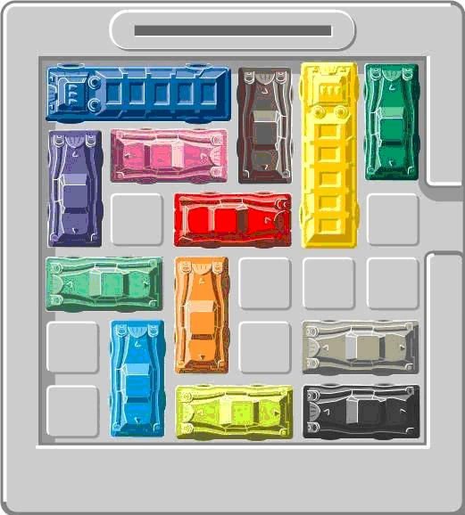¹
Good luck. Have fun. And thanks for your participation!
¹http://www.puzzlesplus.net/images/rush.jpg

